Proof of Testing for number 2

Given points: (1,4) (8,9) (7,5)

Code

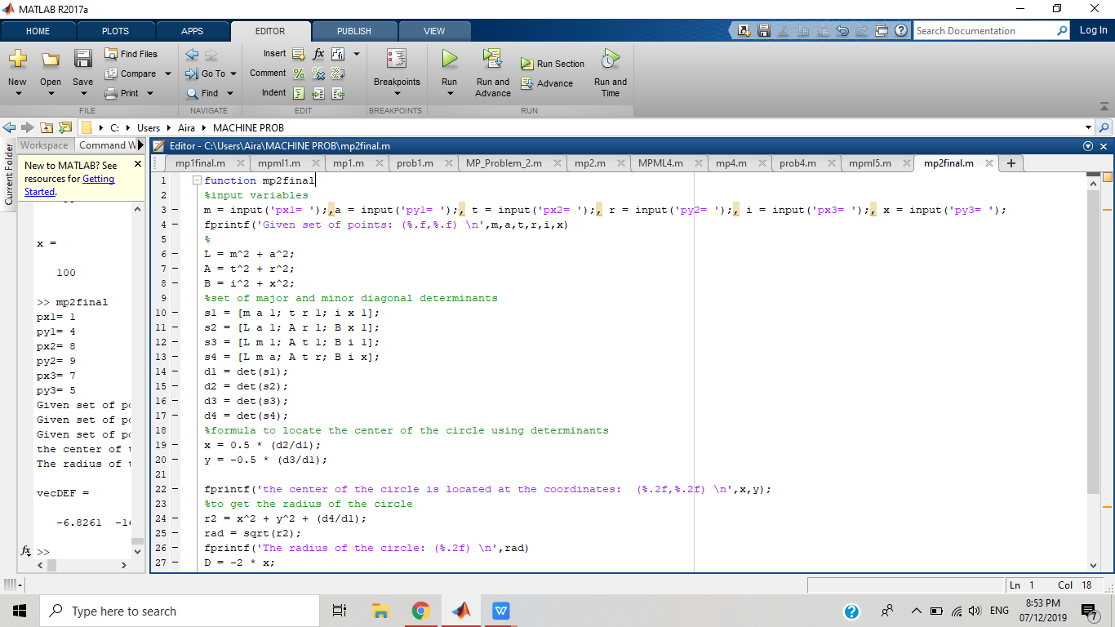

Test proof

